Name : Fariha Arai

AF ID : AF0443236

Lab 18

1. Suppose you have a dataset containing daily temperature readings for a city, and you want to identify days with extreme temperature conditions. Find days where the temperature either exceeded 35 degrees Celsius (hot day) or dropped below 5 degrees Celsius (cold day).

Input: temperatures = np.array([32.5, 34.2, 36.8, 29.3, 31.0, 38.7, 23.1, 18.5, 22.8, 37.2])

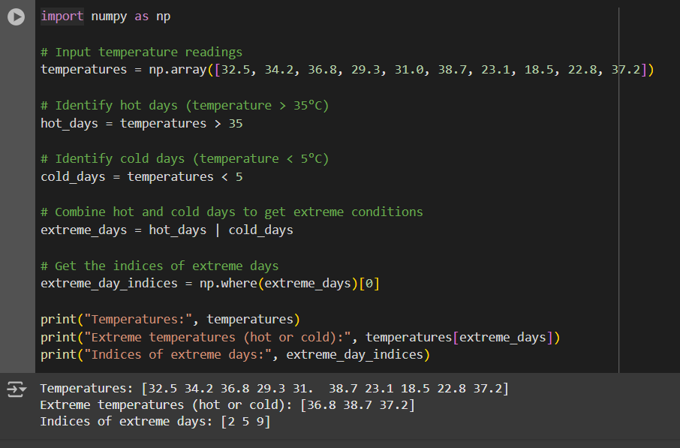

2. Suppose you have a dataset containing monthly sales data for a company, and you want to split this data into quarterly reports for analysis and reporting purposes.

Input: monthly_sales = np.array([120, 135, 148, 165, 180, 155, 168, 190, 205, 198, 210, 225])

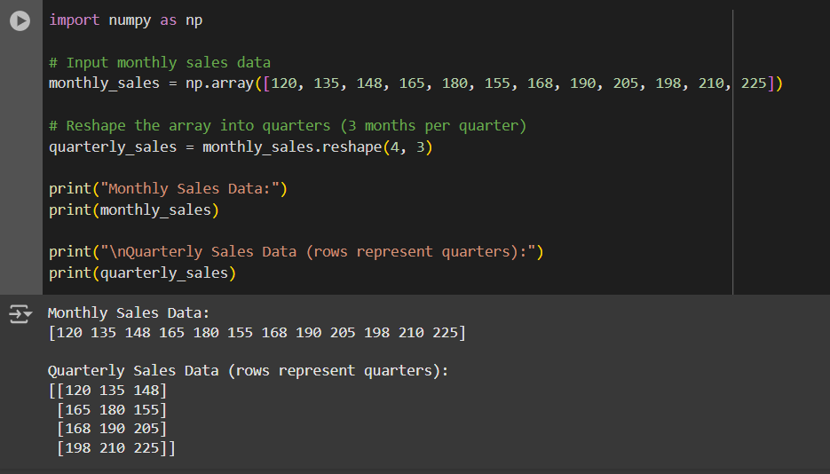

3. Suppose you have a dataset containing customer data, and you want to split this data into two groups: one group for customers who made a purchase in the last 30 days and another group for customers who haven't made a purchase in the last 30 days.

Input: customer_ids = np.array([101, 102, 103, 104, 105, 106, 107, 108, 109, 110])

last_purchase_days_ago = np.array([5, 15, 20, 25, 30, 35, 40, 45, 50, 55])

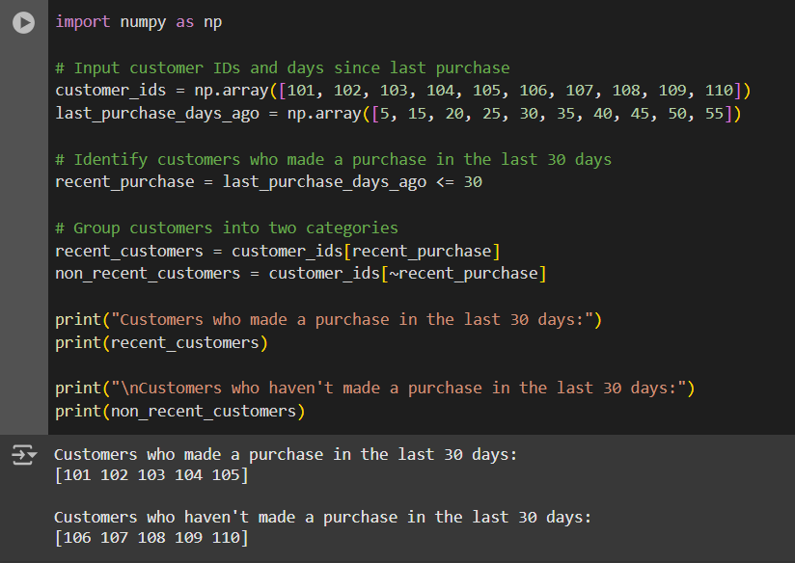

4. Suppose you have two sets of employee data—one containing information about full-time employees and another containing information about part-time employees. You want to combine this data to create a comprehensive employee dataset for HR analysis.

Input: # Employee data for full-time employees full_time_employees = np.array([ [101, 'John Doe', 'Full-Time', 55000], [102, 'Jane Smith', 'Full-Time', 60000], [103, 'Mike Johnson', 'Full-Time', 52000] ])

# Employee data for part-time employees part_time_employees = np.array([ [201, 'Alice Brown', 'Part-Time', 25000], [202, 'Bob Wilson', 'Part-Time', 28000], [203, 'Emily Davis', 'Part-Time', 22000] ])

